The Credit Card Complaints dataset includes information about these complaints, providing a wealth of data for analysis and interpretation. The dataset includes attributes such as the company involved, the company's public response, the company's response to the consumer, the complaint category, and the complaint ID. Other attributes include the consumer complaint narrative and whether the consumer provided consent for the complaint to be shared. The dataset also includes information about the dates the complaint was received and sent to the company, as well as the dimension, issue, product, state, sub-issue, sub-product, and submitted via method.

in this project we will do following steps:

1. extracting data ( in this case from kaggle <https://www.kaggle.com/datasets/datadrivenengineers/credit-card-complaints>)

2. exploring data:

understanding what data contains

3. cleaning and organising data as per convenience

4. creating model view in power bi

5. creating dashboard

6.summarizing conclusion and give suggestion as per data.

Exploring data:

* now as we can see there are following columns include in data:
* Company
* Company public response
* Company response to consumer
* Complaint Category
* Complaint ID
* Consumer complaint narrative
* Consumer consent provided?
* Consumer consent provided? (group)
* Consumer disputed?
* Date received
* Date sent to company2
* Dimension
* Issue
* Product
* State
* Sub-issue
* Sub-product
* Submitted via
* Table Name
* Tags
* Timely response?
* ZIP code
* Avg No of days
* donut
* Number of Records

Note: we are cleaning and exploring data in excel now. Because it is more convenient in excel than power bi. It can also be done in Mysql and jupyter notebook by using python.

* Data cleaning:

first we will auto fit rows and column width to make data look good by selecting all cells. (we can use shortcut ALT + H + O + I for column & ALT + H + O + A)

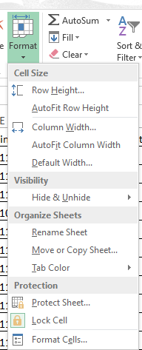

now in last column avg no days it is also showing -1. this is because entries in date received column and date sent to company column are swapped. so we have to fix that issue.

for this I applied following steps:

1. filter rows with avg no of days -1

2. copy filtered table to another sheet.

3. swap date sent and date received columns (refer this video: <https://youtu.be/_2vPmq8tqS4>)

4. delete filtered rows from original sheet( make sure you header row is not selected)

5. remove filter. now we can see there are many blank rows in between.

6. remove all blank rows(refer this video: <https://youtu.be/n_VoUD47gDs>)

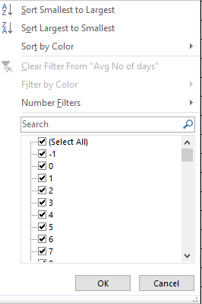

Now to check wheather theare is any date in wrong format or unwanted value we create new column and use formula

=IF((DATEVALUE(TEXT([@[Date received]],"dd-mm-yyyy"))),"valid date","not a date")

all dates are in right format and no unwanted value detected

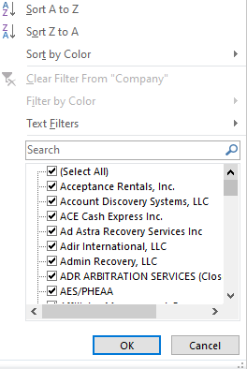

Wherever there is blank we replace it with N/A (Ctrl+H).

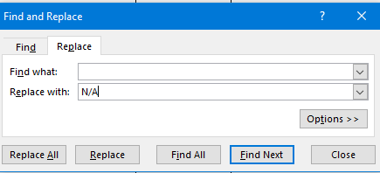

now we have cleaned data. Its time to make dashboards.

first we import and load data from excel into power bi.

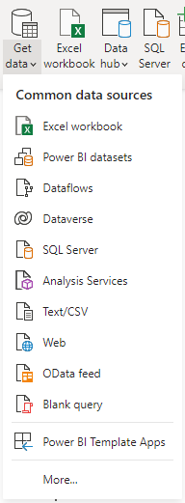

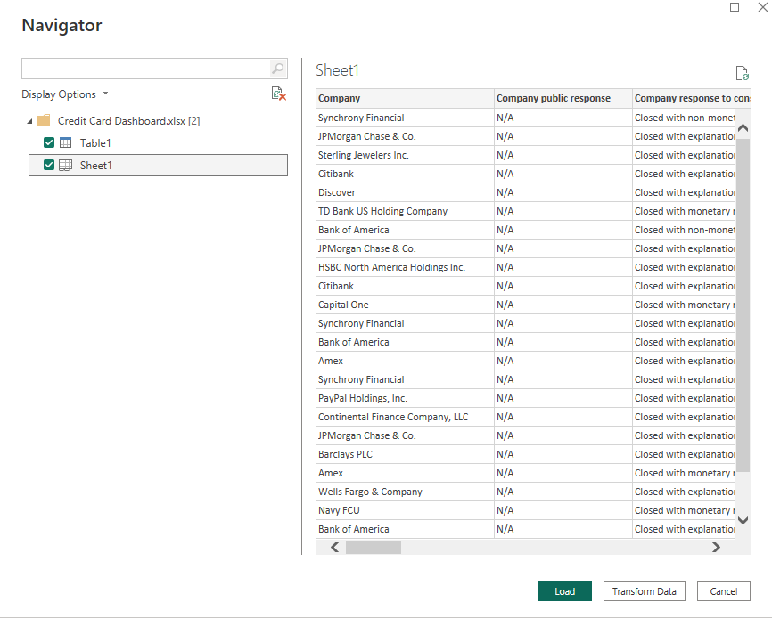

after loading data we check wheather data properly loded or not in data view pane.

Creating dashboards:

now we want to find complains submitted via which mode. For that we created donut chart and exclude N/A value for convenience (because there is only 1 N/A value in column)

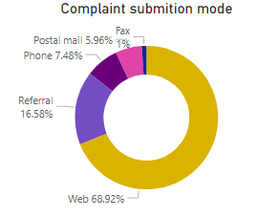

next is top 10 companies having most no. of complaints registered. For that we created a bar chart and apply top N filter to ‘company’.

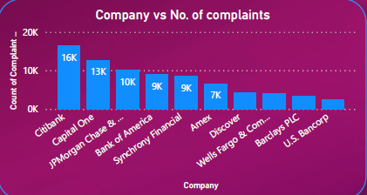

As we see in data stakeholders want to know by which mode companies are receiving complaints. so we created a donut chart to show better and found following results:

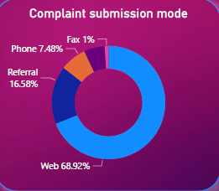

now lets find out what was the company’s response to complaints. For that we took help of funnel chart.

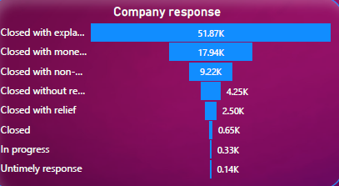

now we want to know from which locations are complaints coming from. Map is best way to show it.

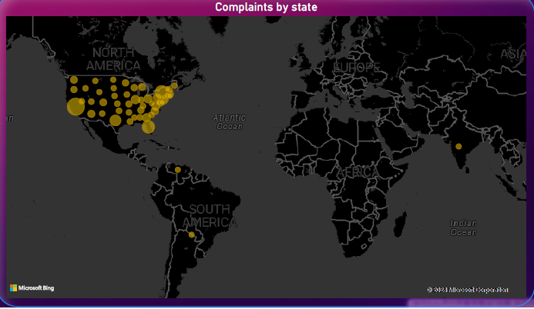

after creating all this dashboards we created another column called “year” and filter out year when complaint is received by company. And then created slicer in tile format.

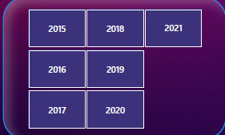

Conclusions :

for conclusions I used summarize to draw insights and add some more myself.

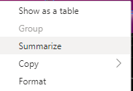

1. Billing disputes accounted for 16.90% of Count of Complaint ID.

2. 68.92% complaints are submitted through web

3. ﻿Count of Complaint ID was highest for Citibank at 16,383, followed by Capital One and JPMorgan Chase & Co.. ﻿﻿Citibank accounted for 18.85% of Count of Complaint ID.﻿﻿ ﻿

4. ﻿California accounted for 13.93% of Complaints which is highest among all states and Palau accounted for lowest complaints.

5. Avg no. of days to resolve complaint is 3 days.